**What kind of businesses are done on the Dark Web?**

The Dark Web has a pretty terrible reputation as a place where criminals and other undesirables congregate for nefarious purposes. While it is true that illegal (or at least frowned upon) activities are rife on the Dark Web, that’s not the whole story. There are actually plenty of things to do on the Dark Web that won’t get you in any sort of legal trouble. The Dark Web is also a haven for people who want the true privacy the internet has always promised. Remember, simply accessing the Dark Web is not a crime. It’s no different from accessing any surface website in that sense. It’s what you do on Dark Web and the sort of content that you consume that has the potential to get you into trouble.

**For the Book Lovers**

For lovers of all things written down, the Dark Web offers some compelling content. Two prominent sites worth mentioning are the Imperial Library of Trantor and Jotunbane’s Reading Club.

**Imperial Library of Trantor -** One of the best deep web links for book lovers. If you love to read deep web books, then you must bookmark this dark web site. They have a vast collection of different category books like fiction, crime, general, mystery, computer etc. Yes, they have almost every category book in their database. As they claim they have 116174 books. This dark web book link also has forum section, you can join them to discuss about books with other forum members. If you want to know what’s the new at Imperial Library of Trantor then you can visit their News section. You can simply search your favorite book by typing in search box. Home page is well designed. You will found Last books added Most visited books and most download books at home page. If you want to read or download the book, just click at book image. You will find two options here, one for read and second for download. You don’t need to look further if you have this dark web link.

**Comics Book Library -** If you are in mood of reading Comics, this hidden web link can be your favorite place. Currently, they have 1201 comics. They have categorized their collection in a standard way for your ease. You can read or short Comic by Title, Comic by Year, Comic by Publishers, Comic by Scanner, recently Added, and Random comic etc. I must say this is the best place at dark web for comic lovers.

**Clockwise Libraries -** This dark web book link has very vast collection of books. Don’t be confuse they don’t offer their collection at home page. To see their books collection, you need to click given book image and you will get their hidden collection of amazing books. They have organized their database in very friendly way. I really like it. They categorized as Alphabetical index of the 48448 authors, the 2293 series, 5127 publishers, 15367 tags, 9 ratings, 25 languages, 51469 books, 50 most recent books. You could take an idea of these records how large collection they have!

**ParaZite -** Parazite has huge collection of secret papers and files. You can access these secret documents by visiting given onion link. Main categories they cover are Documentaries, Porn, History, Weapon, Hacking, etc. This dark web link has some illegal stuff like drugs related research paper, CP documents and much more. If you are interested in know such type stuff, then visit the website.

These are only some of the websites that will provides you unlimited amount of E-Books. There are hundreds of websites to get E-Books. Now, it is illegal to get access to pirated, copyrighted material. Just so you know. However, it’s perfectly fine to join these communities in order to discuss the books themselves with like-minded lovers of literature. So popular is the Dark Web among serious literary aficionados that the Dark Web has its own exclusive literary magazine. It’s called The Torist and it is deadly serious. You’ll find short stories, poems, essays and more.

**Various Clubs**

The Dark Web is littered with special interest sites and forums. Just about any niche activity, you can think of, there is probably an elite, exclusive or just plain weird group of people who get together for the love of it.

For example, *“TheChess”* is a place where Chess fanatics can play online and also while away the hours arguing about which opening is really the best. I’ve also already mentioned book clubs above. They are so big on the Dark Web they deserved their own section.

There are also forums like the Intel Exchange, where you can get information both offensive and extreme, along with more mundane fare. Like a good conspiracy theory? You’ll find plenty here. Along with discussions on things that are considered taboo in many societies. However, talking about taboo things is perfectly legal. Now you can sate your curiosity in true privacy.

**Journalism**

One of the noblest legitimate uses of the Dark Web is putting journalists in touch with people who must get their story out, but can’t afford to do it publicly. It turns out that the flip-side of this use case is also quite welcome on the hidden part of the net.

*“ProPublica”* is at the spearhead of this. It’s a publication which has decided to publish stories on an official Tor site so that readers can access the content with complete anonymity. This deals a deathblow to regimes that don’t allow their citizens to read whatever they like. It’s one of the best reasons to support the existence of the Dark Web. Now, I know that to the people who need to access journalism via the Dark Web are probably breaking laws in their home countries. However in the rest of the free world simply reading an article other people don’t like can never be a crime.

**Search Engines**

Search engines almost literally make the Web work. Without them, you could never find a site unless you had its exact address. Unfortunately, search engines like Google track you across the web. They sell your information and target adverts directly at you. For many people, it’s a fair trade-off given how useful the search algorithm is. However, on the Dark Web, you can get those same search results from the surface web without the possibility of the search engine knowing who you are in the first place.

Many of these privacy search engines are also on the surface web. DuckDuckGo, for example, has both a normal URL and a DuckDuckGo onion site. While using a search engine like DuckDuckGo is already pretty darn private on the surface web, using via Tor means no one will even know you visited DuckDuckGo in the first place. Avoiding the whole guilt by association issue.

**Cryptocurrency Services**

Cryptocurrency is essential to the Dark Web since it is used to facilitate black market transactions. However, just like the Dark Web itself, Bitcoin isn’t illegal by itself.

There is however a problem with Bitcoin when it comes to privacy. It turns out that Bitcoin is quite traceable under the right circumstances. Bitcoin uses a public ledger after all. This also means that Bitcoin you have been paid with can be tainted with ones that have been used for illegal purposes before. New cryptocurrencies like Monero have been developed to solve the issue, but Bitcoin is still the most widely accepted.

Coin tumblers mix up and slice your Bitcoins so that it becomes much, much harder to trace them. It’s a good way to cleanse your Bitcoin from things that have nothing to do with you.

Tumblers aren’t the only Dark Web cryptocurrency services on offer. You can also find exchanges and wallets in the depths of the Dark Web. Just be very careful of being scammed. As long as you don’t use your Bitcoin to buy illegal things, using Dark Web Bitcoin services should be perfectly legal.

**Scientific Papers & Journals**

Believe it or not, it’s actually pretty hard to get your hands on the latest scientific papers. Journals charge an insane amount of money for research papers, none of which goes to the researchers, who would happily give the papers away for free. The rise of Open Access journals has helped a lot, but there is still a significant barrier for public access to direct scientific research. So most people have to get their science news through the lens of popular publications or public science writing. The average person may not care, but it does make life hard for people who don’t have the luxury of a university or corporate research accounts with the likes of Elsevier.

The Dark Web has risen to the occasion, with sites such as Sci-Hub offering access to thousands of papers that are usually behind academic paywalls. Now, depending on where you live this is in a legal grey area. So you might want to Google (or DuckDuckGo) the legality of Sci-Hub in your region, but one way or another it’s an amazing resource. It works by crawling university databases and other deep web resources looking for papers people have requested. At last count, the total number of papers was climbing steadily to the 50 million mark. That’s incredible.

It’s not the only game in town either. For example, there’s also the American Journal of Freestanding Research Psychology. Although this is actually meant as a Dark Web psychology journal.

**Social Media**

Social Media websites are getting popular because of the growth of concerns about privacy of users. Social media still has a place in the online world. Plenty of people enjoy the simple act of sharing and interacting. However, the big social media platforms like Facebook don’t let you use an anonymous identity. For example, Facebook has a dark net site which is used by over a million individuals every month. Several Dark Web alternatives to Facebook have popped up over the years. Blackbook and Torbook are common examples, although sites using those names come and go. Such sites are designed to look and feel like Facebook. You sign up with a fake or isolated email address and set up an anonymous profile. Obviously, you should not put any personally identifiable content on these sites.

Ironically enough, there is a Facebook onion address. It’s useful for people who want to access Facebook without their governments knowing, but you’re still subject to their real name policies. So make of that what you will.

**Cybersecurity**

There are certain advantages to the enterprise in being able to use the dark net for enhancing network and customer security. There is a wealth of information on dark net forums which can alert cybersecurity teams about potential vulnerabilities or emerging threats. Advanced intelligence on new hacks that are being used against them, or knowledge of tools like botnets or compromised servers, can offer enterprises significant cost savings when developing their cybersecurity methods. Active involvement in monitoring dark net activity can also be extremely useful in guarding against phishing attacks, for example, or when customer data has been breached and appears for sale on the dark net.

**Secure Communication**

The prospect of secure communication can be attractive to news organizations who can use it to communicate with their sources. As a result, investigative reporting organizations like Propublica (https://www.propublica.org/) now have their own dark net sites. And there is also an increasing use of the dark net by other types of institutions, like the UN, which uses it to monitor activity that it shares with the police and governmental groups.

**ProPublica** – ProPublica was the first major news organization to launch a version of its site on the dark web, catering to readers who need or prefer to stay anonymous online. As Wired reports, the publication launched as a "hidden service" on the Tor anonymity network on Wednesday, guaranteeing readers that internet service providers or other snoops won't even be able to see that they've visited the site.

Users could always anonymously access ProPublica through a Tor browser, but not all of the publication's pages are protected with SSL encryption, leaving open the possibility that eavesdroppers could see what content they look at. Even if a user doesn't visit a non-encrypted ProPublica page, others could still see that they had visited the site. Operating as a hidden service negates those risks, the news outlet says. Tor hidden services mask a website's IP address, and can only be used when running Tor software.

**Business Intelligence**

One of the original functions of the Tor network as a government-sponsored initiative, was to ensure secure communications. As such, the dark net has arguably always been an ideal medium for the gathering and sharing of intelligence. It is hardly surprising that enterprises have also begun to see some competitive advantages in using the dark net in this way. There is a vast range of data on the dark net – so-called ‘dark data’ – which enterprises can use to develop customer insights, such as better understanding of consumer preferences. Dark net data can also be mined to refine operational, marketing, and new product insights. Enterprises can gather this intelligence themselves, but increasingly there is a developing industry that provides dark net information to the enterprise.

**Credit Monitoring**

Several credit rating firms, like Experian38, already offer services for customers to check if their details (SSN, phone number, ID info) are on the dark web. This suggests there is the potential for lenders or other credit agencies to build in extra safeguards when underwriting loans, by acquiring insights from the dark net when looking into the credit history of applicants.

**Recruitments**

There is also evidence that some enterprises are making use of the dark net as a tool for recruitment as it provides a novel way of reaching a community that is potentially out of reach to traditional recruitment agencies. One example was the campaign run by an anonymous organization calling itself Cicada 3301, which posted a series of complex puzzles that eventually took candidates into the dark net. The identity of the organization remains mysterious, but there are obvious precedents here for imaginative recruitment. When combined with the kind of enhanced intelligence about job candidates offered by the dark net, it seems clear that HR and job recruitment is one of many aspects of business operations likely to evolve as use of the dark net develops.

**Intel Exchange**

The Intel exchange is pretty much what you’d expect based on the name. It’s a place where people come and exchange “intel” in the “intelligence” sense of the word. Valuable information in all manner of topic areas.

People share information here that you wouldn’t normally expect. A lot of it is of course just crazy and untrue. Plenty of conspiracy stuff and the like. So basically like Wikipedia, but with even less vetting.

The range of topics is impressive. Supposedly suppressed technologies get discussed in its own sub-forum. People provide insider info about current events or things related to current events.

There are also more mainstream topics such as computer hardware, software, mathematics and more. Read the Intel Exchange at your own risk, but it’s sure to be a fascinating experience.

**Demography of the e-commerce of Dark Web**

According to the statistics of Statista, in 2019, 12% users from the total users of internet worldwide have used some technologies that allows access to the dark web.

A screenshot is given on the next page from the statistics made by statista:

As we can see, India is topping the list with a number of users of 26% of total users who have access to the dark web. And other countries are listed below with percentage:

* Russia 22%
* Brazil 21%
* Indonesia 20%
* Turkey 16%
* South Africa 16%
* Sweden 16%
* Mexico 13%
* Korea 12%
* Poland 12%

And so on.

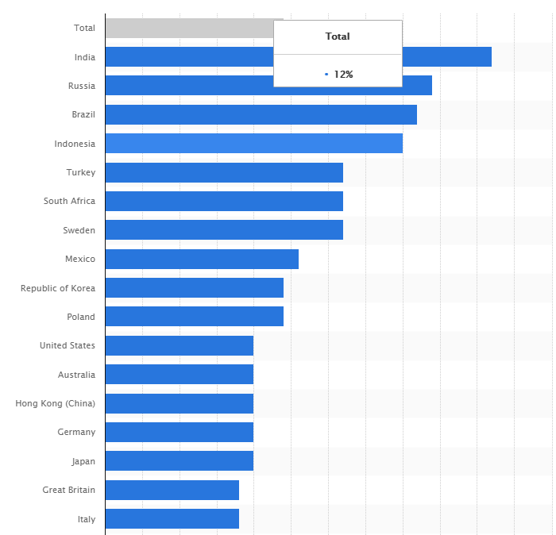

**Some statistics & facts of Dark Web**

**At least 100 darknet marketplaces were active 2019:** Darknet marketplaces are where one can find everything ranging from marijuana to rocket launchers. There would be sellers offering credit card info and email IDs too. Human trafficking is often associated with these marketplaces, as well.

Authorities around the world are trying to shut down these marketplaces and have done so successfully on many occasions. However, new marketplaces are cropping up at a higher pace on the Dark Web, and there is always a cat and mouse chase between the authorities and marketplaces.

**The Dark Web made FBI the second-largest owner of Bitcoins:** As the authorities cracked down the operations of Silk Road, the subsequently confiscated a lot of bitcoins from various accounts of Ulbricht. They got 144,000 bitcoins from Ulbricht’s rented servers in Iceland.

FBI has still done nothing of these bitcoins, and their current aggregate value is around $1.2 billion. It will be interesting to know how FBI plans to deal with all those digital assets.

**Information from 620 million accounts was available for sale on the dark web:** We often come across the news of hackers getting into website servers and stealing away account information of millions of users. If you ever wondered, what would one do with these millions of accounts, then selling them is one of the answers. And, no points for guessing it right, hackers come to dark web to sell such data.

A report showed that account information stolen from 16 websites, making up for 620 million user accounts, was on sale on the darknet. Not all the compromised websites knew that their servers were breached. All the data was mined over one year, and at least one person bought it.

**The job opportunities on the dark web:** You never know what you may find on this part of the internet. There was once a job posting that said one could earn $255k on serving for six months. The job description had nothing much to give user an idea of what’s going on.

All it mentioned was that it was a six months job, the person would stay out of communication, and the one applying for the job should have some combat experience. One can only wonder what kind of job it can be.

**Bitcoin helps this digital black market survive and thrive:** You already know that dark web provides all kinds of things and services that one can possible thing of getting. Marketplaces on darknet perform in a way similar to one on surface web. Since identities are often masked, sellers often maintain the same alias.

Buyers leave reviews of stuff they buy on such places, and it is these reviews that help other buyers to know if they can trust a seller. Reviews are of utmost importance on such forums. The one thing which is at the foundation of such a huge business is cryptocurrency.

**Dark Web Timeline**

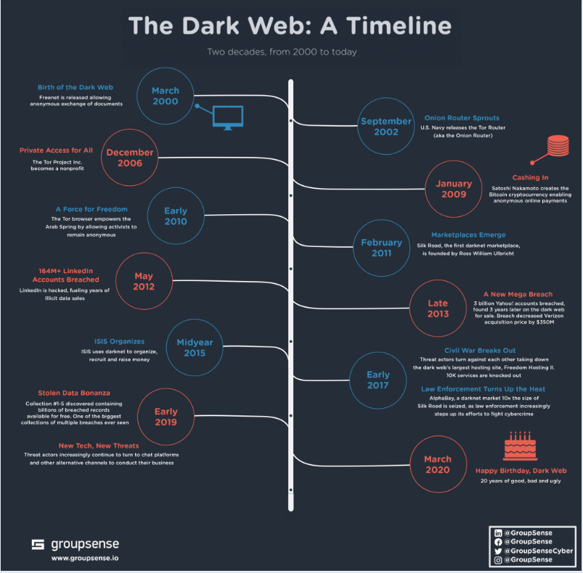

**Market Comparison Chart**

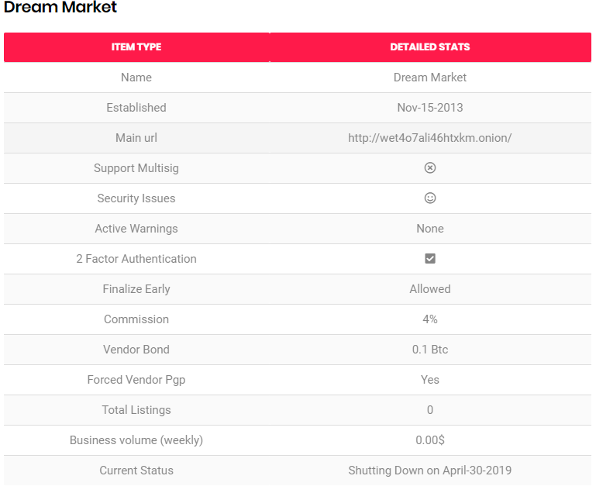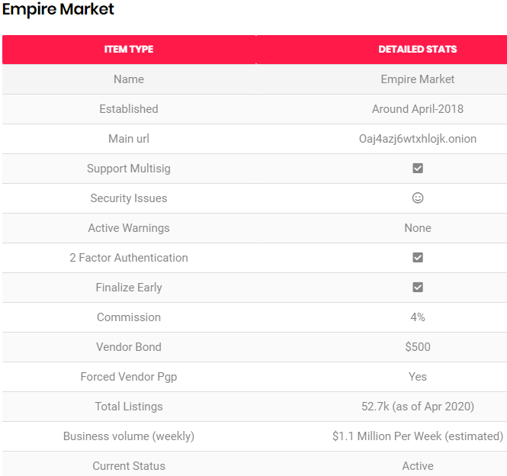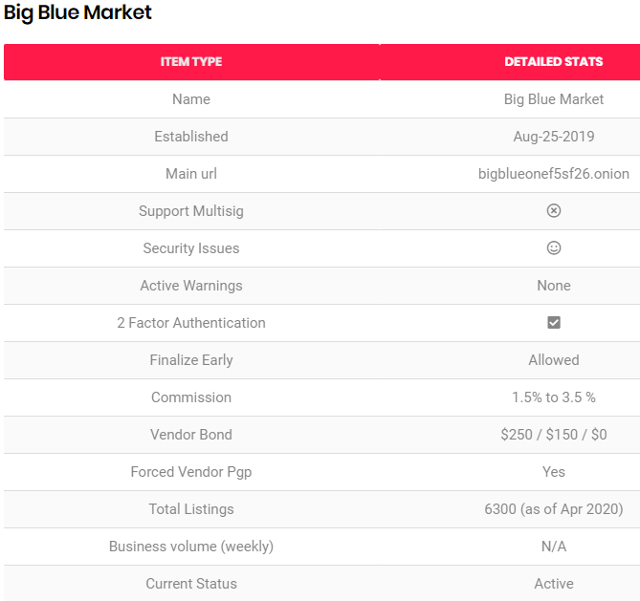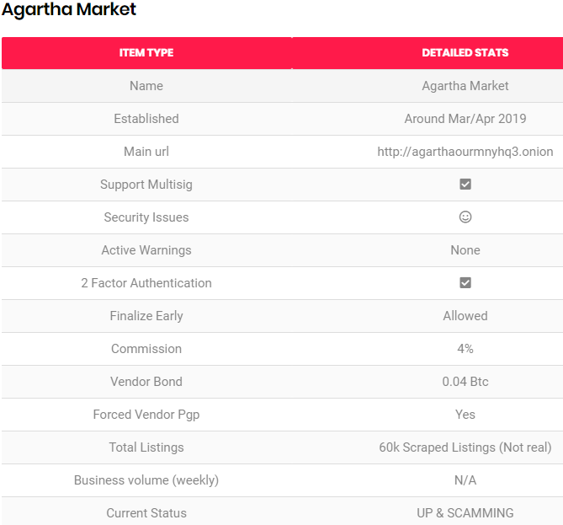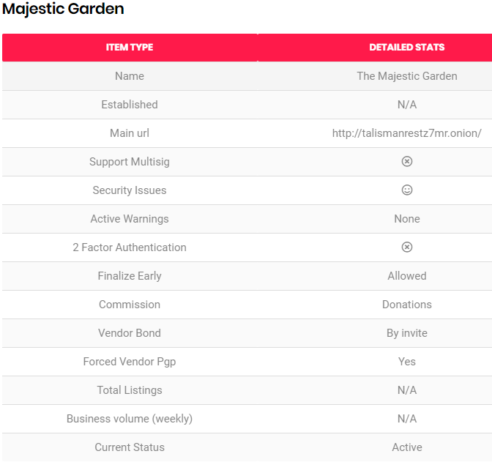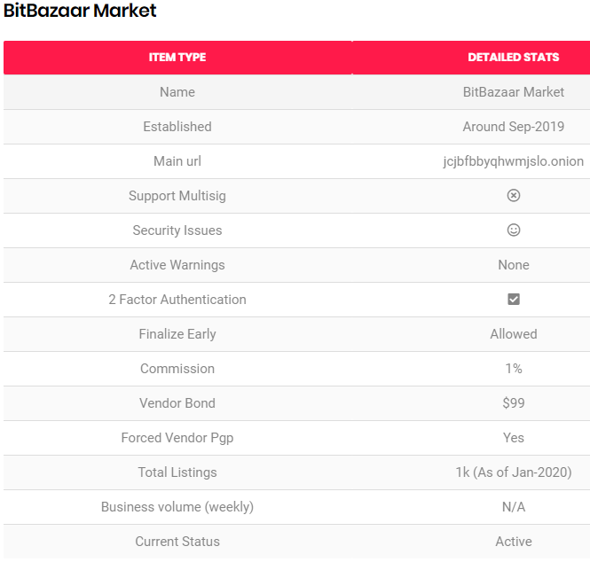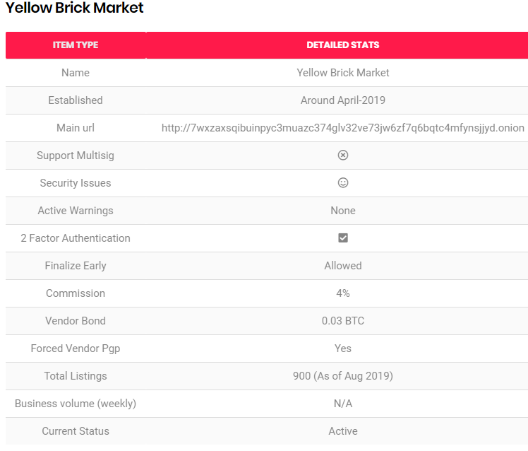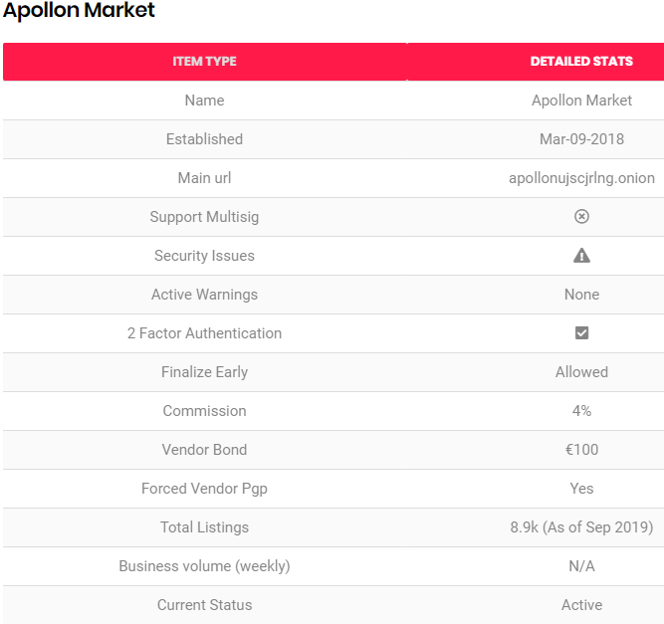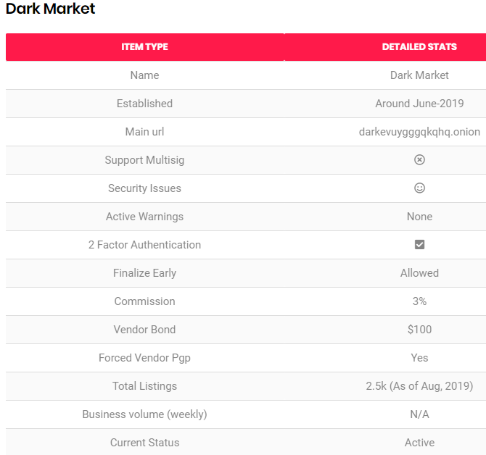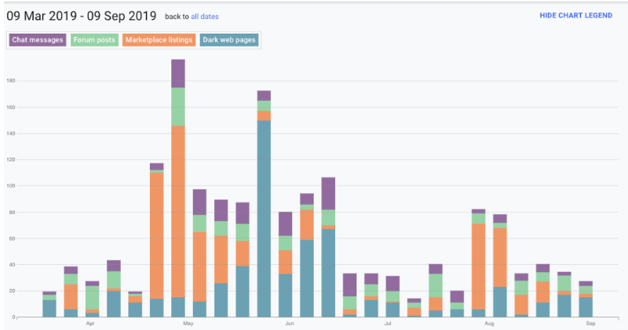

**Stories/Anecdotes of Dark Web**

**Wish Pills:** One person found "wish pill" on a darknet market. Here is the description –

Basically you take the pill, make a wish and it's supposed to make it come true. It just made me laugh how much they were trying to sell it off as something real, they made up fake elements that were supposedly found in nature and showed videos of them "making the pill" (Which was really just a bunch of blue lights being flashed at the screen). They were selling it for a $100 a pill, sad thing is there were probably a few idiots who actually bought it.

**The whole horn:** Sometimes you may need something specific and you have nowhere else to turn. If that's the case watch out for a steep price tag. This Redditor explains –

*“A few years ago I went searching for rhino horn for a story, one guy said he had a couple of whole horns he'd sell for six figures. I had to pass.”*

**A mind-blowing experience:** Surprises are often in store. And so are vendors with senses of humor. As is showcased with this story –

*Silk Road. Circa 2013. Purchased what was promised as a "mind-blowing" experience. Received a Dust Buster two days later. Strangely, no complaints on my end.*

**Survival guide for prison:** From Quora –

*There was an interesting PDF with easily 1,000 pages written by ex-inmates about how to survive in prison, how to get drugs in and out of prisons, gangs etc.*

**Don't forget the simple things:** And sometimes people are selling things you didn't even know you needed to buy online, like carrots or pretzels. There was a German man selling pretzels, just pretzels.

**Most of the deep web isn't accessible**: One Reddit user explained that most things on the deep web simply aren't visible to the average person — they're hidden behind passwords or aren't linked to on any other websites. Most things that are visible on the deep web are visible because someone wants them to be. Everything else generally isn't easily accessible.

**Mariana’s Web:** This is one of the most uncertain dark web stories out there. Mariana Web is a supposed hidden site with information on secrets about the earth. The site is named after Mariana’s Trench, the deepest point on earth because Mariana’s web is buried very deep even on the deep web. It is believed that this site exists even though there is very little evidence to show that. The site is reported to contain information about communication with other life forms, the location Atlantis, and a subset of the internet used extra-terrestrial beings to monitor us.

Anonymous $255,000 Job: Some deep web stories have very few incentives to attract people but this particular one promises people $255,000. Aside from the fact that being a job listing on the dark web makes this a scary offer, the job description is extremely ambiguous offering only the points listed below as what is needed for the job.

* Combat experience
* 6 months on a ship
* No communication with the outside world
* $255k is the total payment for 6 months

**Five Guys:** According to a Reddit post, "Was on Tor, browsing da usuals. Go out to eat foods at the Five Guys. Come back. More Tor. Find a picture of me eating at Five Guys.”

**Mysterious Logins:** This isn’t so much a single story, but more of a mystery from the Dark Web itself. While most hidden services on Tor are actually pretty easy to find thanks to links on the clear web, not everyone is so welcoming.

There are numerous sites on Tor that are a complete mystery. If you visit them you’ll just see a nondescript login page. There’s not even a tiny clue as to what sort of sites lie behind these stony digital walls. It could be a cult, the FBI or something too horrible to imagine. All we can do is pretend they don’t exist or become obsessed with these mysteriously locked doors to some sort of even darker web.